**Linux Basic Commands Assignment**

1. Create a file like nano file1.txt

o Edit some data and then save the file

**Steps done:**

1.Created nano file1.txt

2.press ctrl+x and afterward press “y” to save changes

3.Hit enter to exit from nano editor

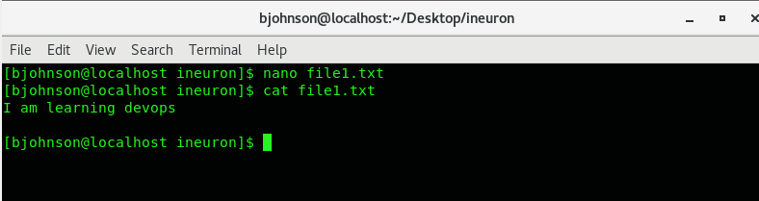

2. Now we will copy date from file1 to new file2

o cp file1.txt file2.txt

o Then see the output of file2.txt, cat file2.txt

o Give screenshot

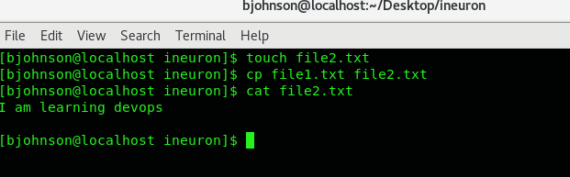

3. Now we will move the file2.txt to new folder /home

o mv file2.txt /home

o Then go to home directory and check ls, file exits or not?

o Given screenshotz

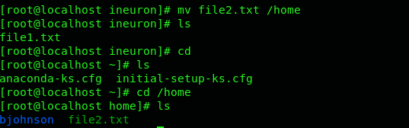

4.Then we create a new file3.txt and file4.txt in home directory and add

content in it.

o Now do echo “Hello I am newline” > file3.txt and provide the

output of file3.txt



o Now do echo “Hello I am newline” >> file4.txt and provide the

output of file4.txt



o Tell the different between both step you follow and the reason

behind it

The difference is:

Using > overwrites the content of text file with the new string

While >> adds the new string to the existing content

As per the above there was no much difference because there was 2 different files if we use same file with different string and methodology(>,>>)

Ex:

Using >>



Using >



5. For remove a file or directory you can use the below two commands

To delete a file – rm <any_filename>

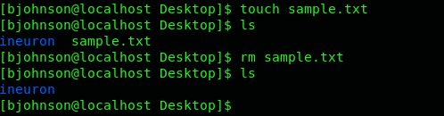

To delete a directory -rmdir <any_directoryname>

